Fuzzy

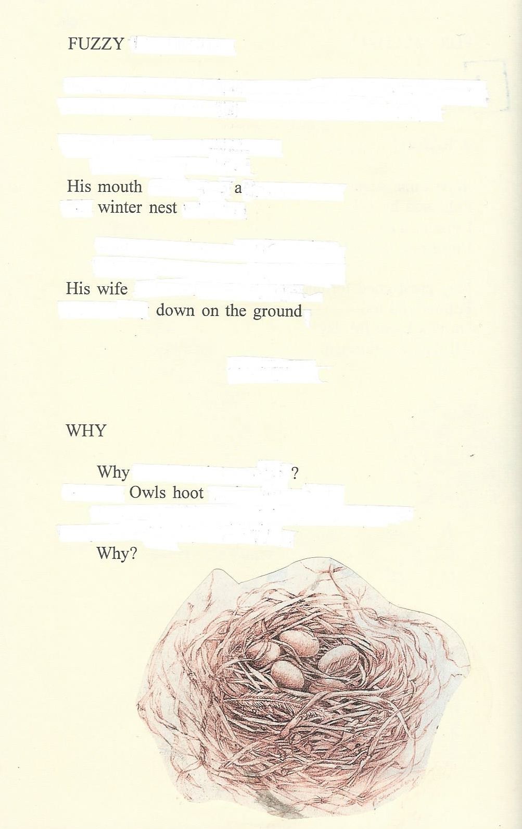

Source text: Emily Wright. “The Sands of My Life.” Tales of the Mojave Road Publishing Company, 1994.
My Critic

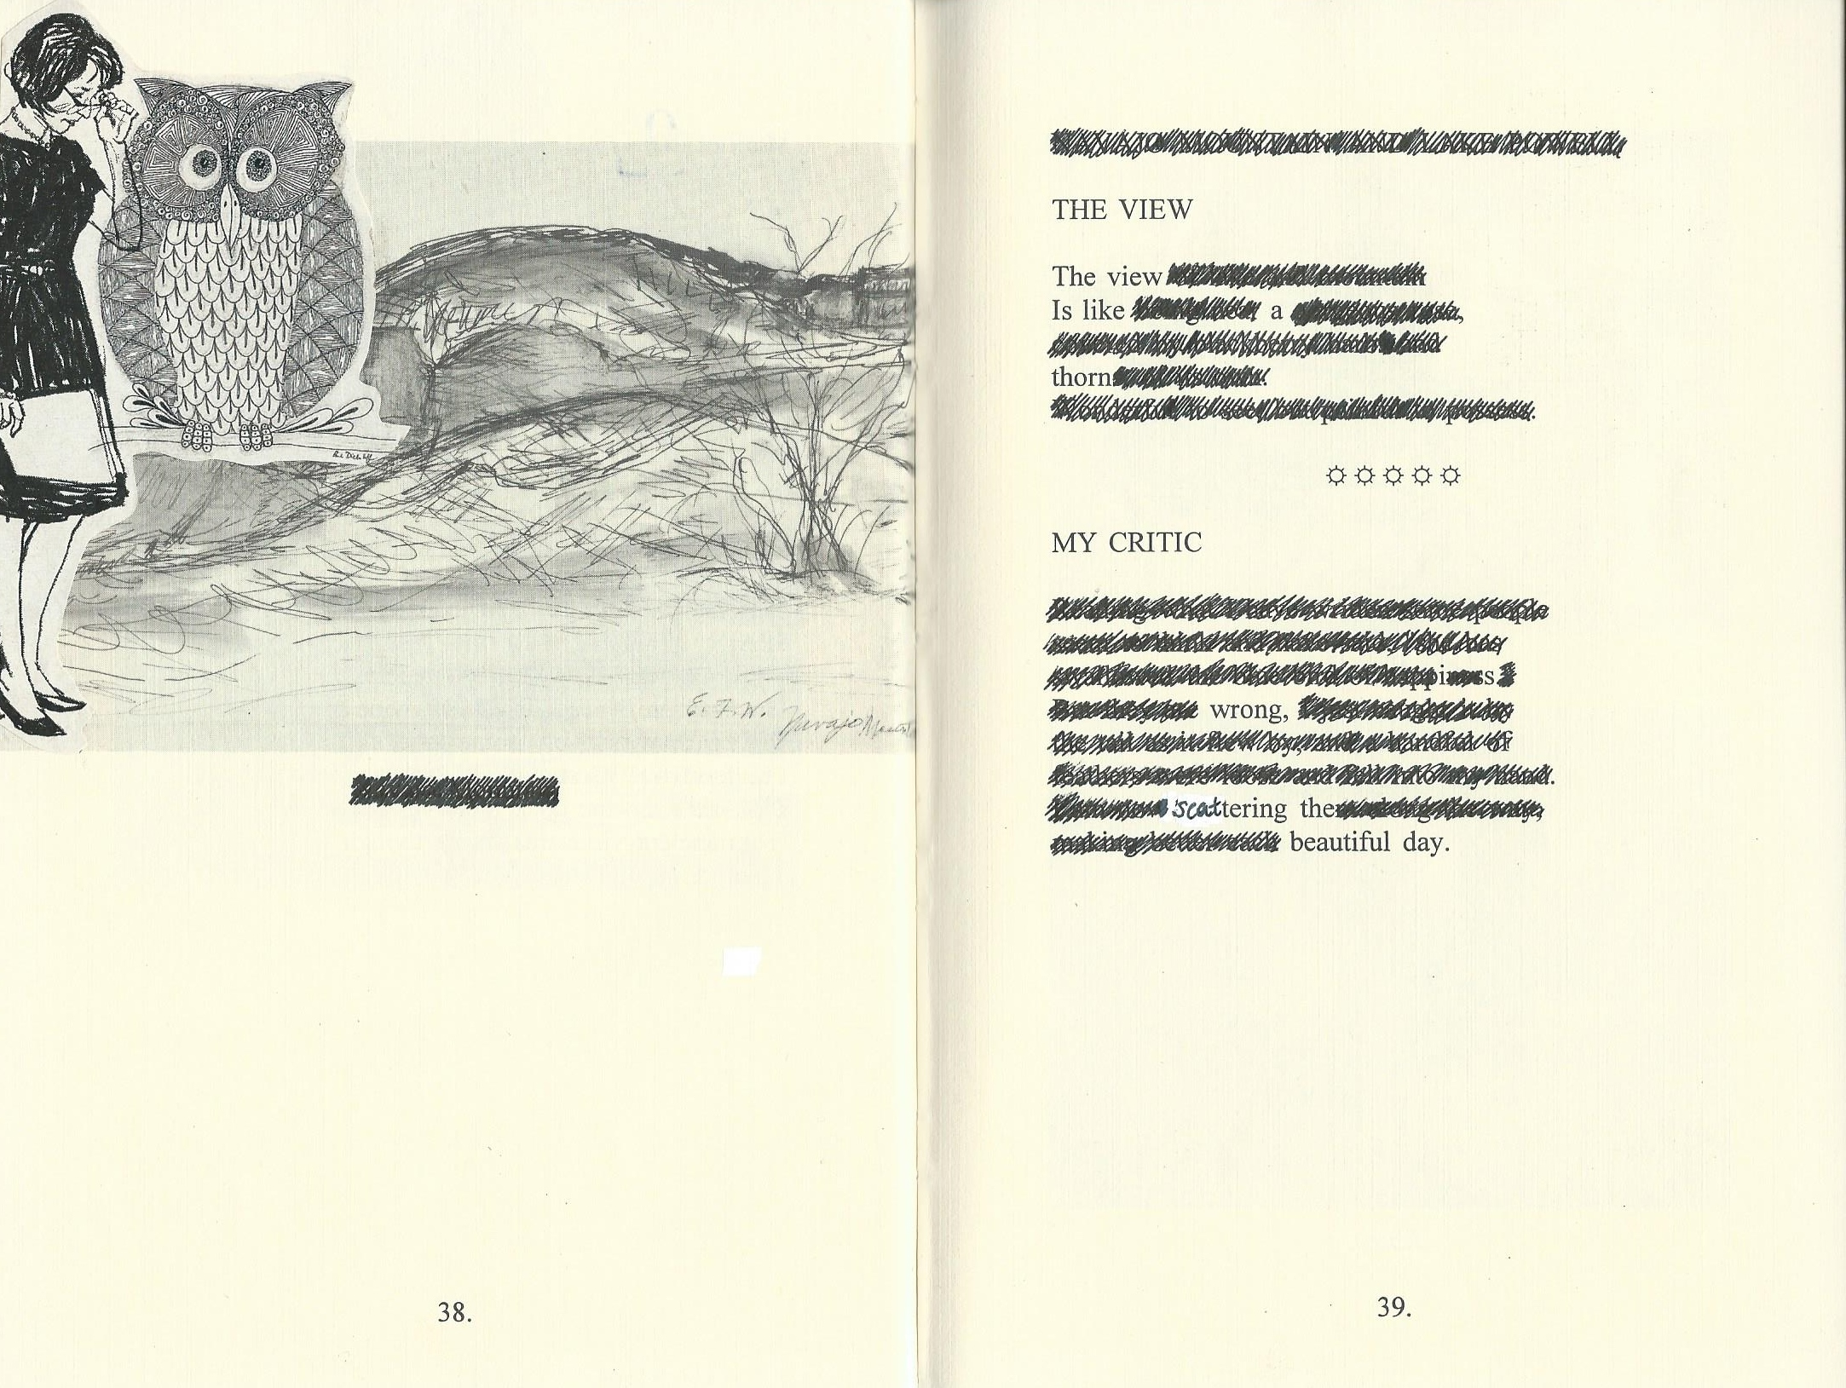

Source text: Emily Wright. “The Sands of My Life.” Tales of the Mojave Road Publishing Company, 1994.

Interrupted

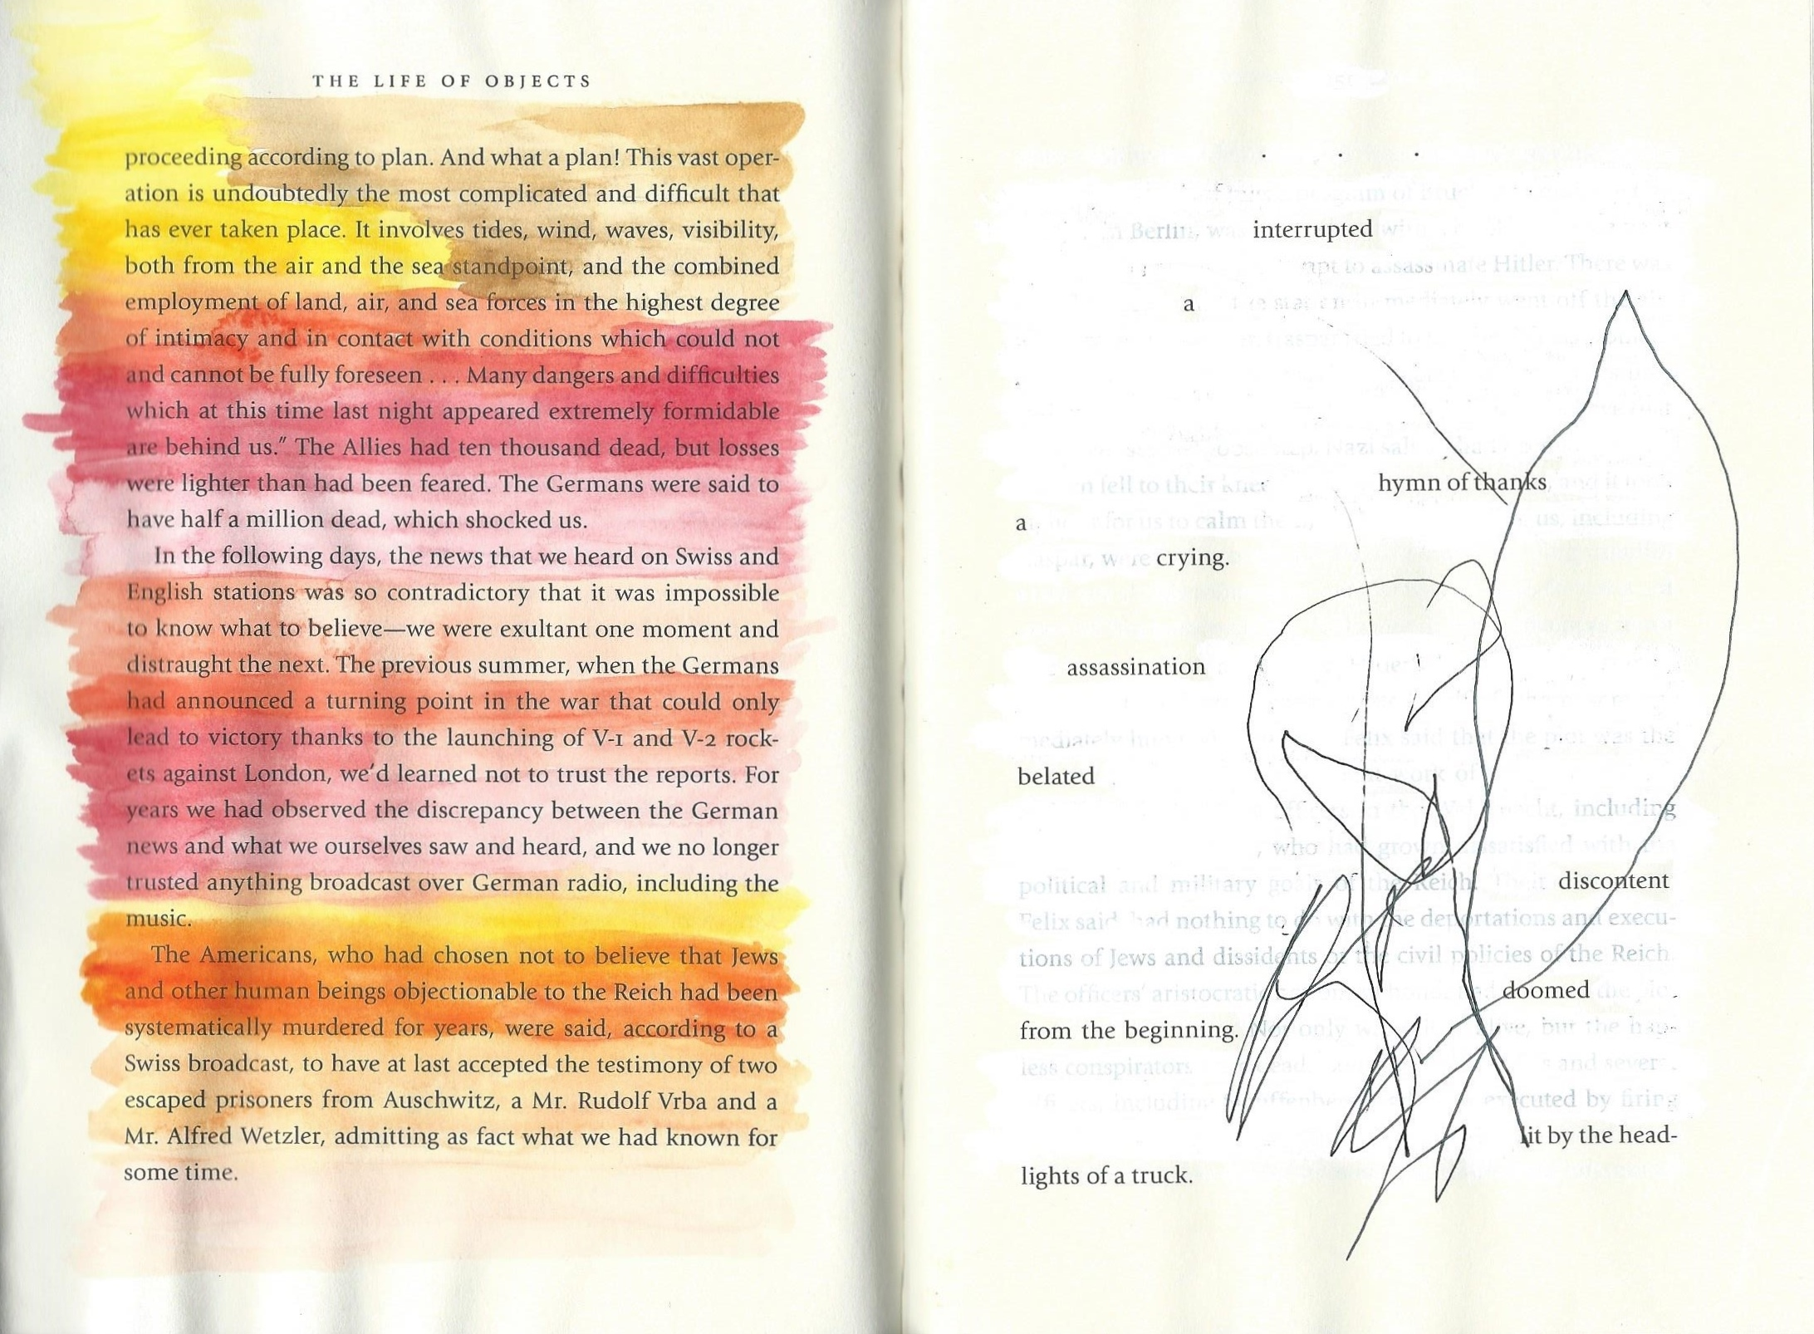

Source text: Susanna Moore. “The Life of Objects.” Vintage, 2012.

